Meeting Room Reservation Request Form
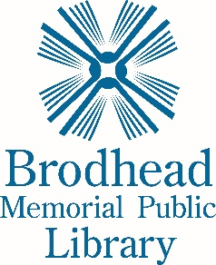
1207 25th St * Brodhead, WI* 53520*608-897-4070
Meeting Date: __________________________
Number of Persons (estimate): _____________________________________________________
Meeting Time (include setup & cleanup): Begins_______________ & Ends_________________
Wish to Use: Meeting Room Only____________ Meeting Room & Kitchenette______

Your Information  Applicant:______________________________________________  Daytime telephone:______________________________________  Evening telephone: ______________________________________  Cell number: ___________________________________________  Email address: __________________________________________  Applicant’s postal mail address: ____________________________  ______________________________________________________  Do we have permission to give your name and phone number to the public?  - Yes  - No | Your Organization  Name of Organization:_____________________________  In what community is your organization based?  _____________________________________________________  Purpose of the Meeting: _________________________________  _____________________________________________________  Organization’s postal mail address: _________________________  _____________________________________________________  ______________________________________________________  Organization’s telephone: ________________________  Non-profit tax ID #: ______________________________
- I have read and agree to be bound by the Brodhead Public Library Meeting Room Policy.
- We will leave the room clean and arranged as posted.
- We will check the restrooms and hallway areas for remaining people or other problems and report any issues to the Brodhead Police immediately at 608-897-2112.
- I understand that while using the meeting room and/or kitchenette, no admission may be charged, and no products or service may be advertised, solicited or sold.
- If the key is lost, I understand I will be charged for all the costs associated with rekeying the Meeting Room & Foyer. There is a deposit of $50.00 require for key use. Addition Persons Authorized to pick up keys for this reservation (please list): _______________________________________
- I will notify the Library 24-hours before cancellation.
- I understand that failure to comply with the Library’s policies may result in the loss of use of the meeting room.
- I understand this request becomes a reservation only after the Library has confirmed it.

Signature of applicant and person responsible: ______________________________________________________Date Signed:___________
Staff use Only
Key# _________Dated Checked out _____________Date returned _________State of room _____________________________________________________________
Updated 7/21/2015

